**Boston AirBnB Analysis:**

I’m considering the audience as “the public” here, as it's important for travelers or guests to estimate the price range for different accommodations. At the same time, this data is valuable for property managers and hosts as it provides a clear picture of market availability, enabling them to evaluate their competition and spot potential opportunities.

The filter “Avg. Price” is applicable over all visuals on the dashboard for interactivity.

1. Horizontal bar chart: property vs price:

The horizontal bar chart illustrates the average prices for different property types, ranking the top 5 by their average costs. It reveals that "Room in a boutique hotel" has the highest average price, whereas "Entire home" is the least expensive among these top 5 options. This visual guide helps prospective travelers understand the cost range for various accommodations, assisting them in making budget conscious decisions.

The bars are colored similarly to group them based on the room type, while their horizontal alignment emphasizes their comparability. The use of labels directly on the bars eliminates any ambiguity, aiding in quick comprehension. The chart layout directs the viewer's eye from left to right, supporting a natural reading flow and helping the audience quickly grasp which property types are more expensive.

1. Map:

The map displays the geographical distribution of Airbnb listings with their average prices, neighborhoods, listing and picture URLs, host acceptance rates, etc. This map offers an insightful view into the pricing and availability of accommodation across different neighborhoods, highlighting high acceptance rates. The audience can filter the data based on prices according to their budget and use other available filters for convenience.

The map utilizes the **enclosure** principle by clustering areas with higher concentrations of listings, making it easy to identify popular neighborhoods. **Colored** dots help in identifying budget-friendly locations. The map's interactive elements, such as filters, provide additional details like average price ranges and acceptance rates, enhancing the user's ability to compare listings. This interactivity aligns with the user's need for detailed information without overwhelming the initial visual layout.

1. Single value1: availabil AirBnB’s

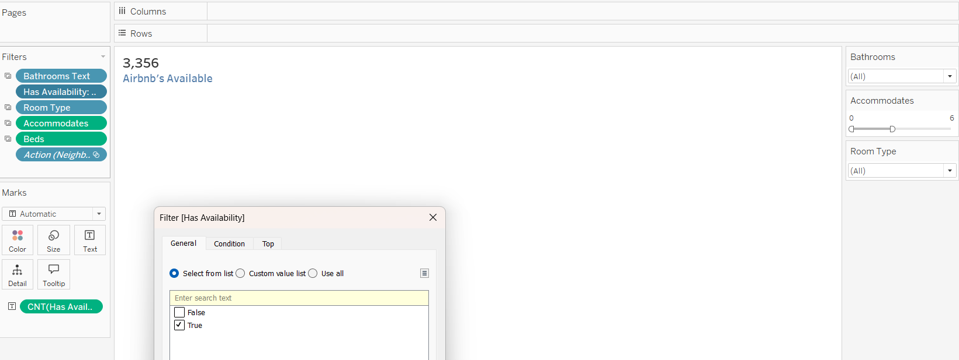

It represents the count of available Airbnb listings, filtered by availability status (i.e. true). It provides a clear snapshot of the market's current state, useful for the audience to book their next stay.

This is a simple single value chart which uses closure and connectivity principles to deliver precise data and engages users with clear visuals.

1. Table:

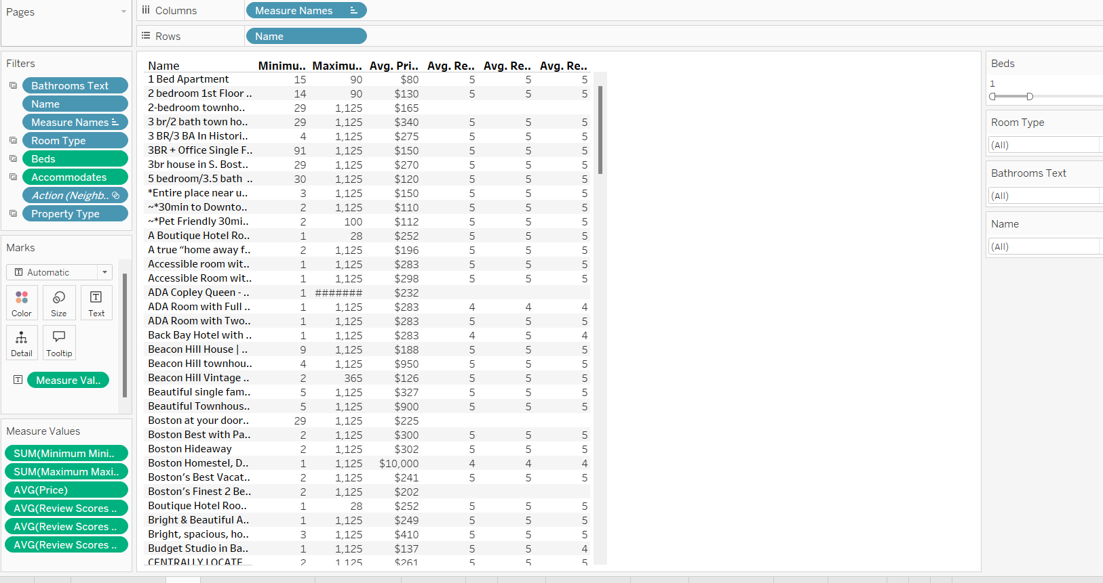

The table outlines detailed information about different listings, including the range of stay durations, average pricing, and review ratings for aspects like cleanliness and location. It serves as a helpful tool for users to compare and evaluate various attributes of multiple listings.

Proximity: The columns are arranged near each other to simplify the comparison of various attributes between listings.

Similarity: Consistent formatting in both rows and columns helps users efficiently scan and interpret the information

1. Stacked bar chart: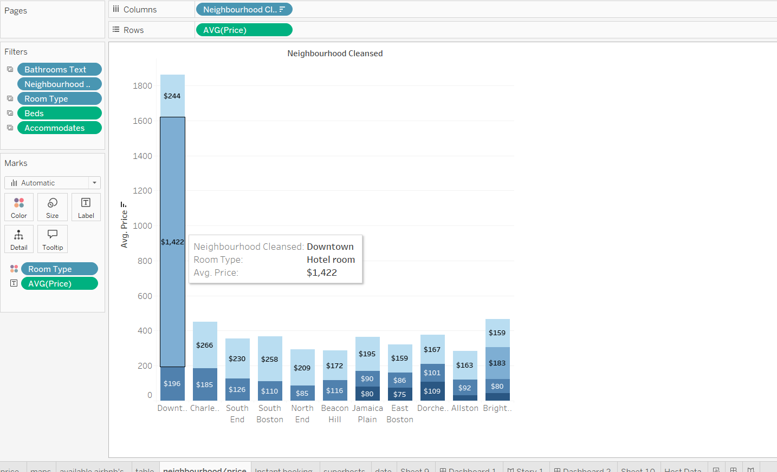

This bar chart shows the average prices of listings in different neighborhoods, with Downtown notably having much higher prices than the others. Downtown is identified as the costliest area, with an average price of $1,422 per listing (subject to change with different filters), indicating a high level of demand.

Proximity and Similarity: The bars for each neighborhood are positioned close together and share a consistent color scheme, which makes comparing prices across room types straightforward. The distinct color contrast between the bars and the background enhances data visibility, making it easier to identify differences in room types.

1. Single value2: instant bookableA screenshot of a computer

   Description automatically generated

It displays the number of accommodations available for instant booking among the listed Airbnb options, assisting travelers in making their reservations.

Like the previous single value, this straightforward text uses closure and connectivity principles to deliver precise information efficiently, engaging viewers with its visual presentation.

1. Single value3: SuperhostsA screenshot of a computer

   Description automatically generated

The figure displays the count of superhosts with listed accommodations, providing a view of their experience level. This count can vary depending on filters like average price, property type, room type, number of bathrooms and beds, and the accommodation’s guest capacity.

Like the previous single value, this text is straightforward and employs closure and connectivity principles to offer precise and immediate information. The use of interactive filters enhances its effectiveness.

1. Single value4: data last scrapedA screenshot of a computer

   Description automatically generated

It indicates the most recent update date of the dataset so users can gauge the freshness of the information. Similar to the previous single value, this text employs closure and connectivity principles to offer clear and immediate information to the audience.

1. tree map: Host dataA screenshot of a computer

   Description automatically generated

The tree map visualizes host-related data, emphasizing the connections among host verification status, average accommodation price, superhost status, and response rates.

Color and Size Indicators: The segments are color-coded and sized based on the average price of accommodations, facilitating the easy comparison of high and low prices. Additional host details are accessible via the tooltip text.

Interactive Tooltips: Tooltips offer more detailed information about each segment, including response rates and locations, providing deeper insights while maintaining a clean visual presentation.

**

The dashboard provides a detailed snapshot of the Boston Airbnb market as of March 19, 2023, aimed at travelers searching for accommodations. It includes crucial information like average pricing, details about the listings, and host response rates, segmented by filters such as property type, room type, and neighborhood. I selected these visuals as they highlight differences in pricing, host responsiveness, and the distribution of listings, helping prospective guests quickly grasp pricing patterns and assess host reliability across various areas.

The dashboard focuses on key features such as pricing trends and host response rates, which help travelers make informed decisions. It includes interactive filters that let users select specific criteria, like superhosts or property types, improving the tool's usefulness. With various visual elements like maps, bar charts, and tables, the dashboard offers a comprehensive view that balances broad trends with detailed information. This user-friendly design makes it easier for travelers to find and understand relevant details for their accommodation search.

**Story:**

The creation of the visuals began with a thorough analysis of travelers looking for Airbnb accommodations in Boston. I identified key metrics relevant to this group, such as average pricing, listing availability, bed and bath counts, host response rates, and verification status. I developed interactive charts that offer a detailed market overview, enabling users to filter by property type, room type, and average price. I also added functionality to the stacked bar chart to allow users to view and interact with all charts based on room type. No extra calculated fields were necessary.

The primary challenge was balancing detailed information with a user-friendly design. It was challenging to include sufficient details on the dashboard without overwhelming users and causing disengagement. Additionally, dealing with inconsistent and incomplete data, such as missing host response rates and verification statuses, required careful filtering to ensure the accuracy of the visualizations. Keeping the dashboard both informative and easy to navigate was crucial.

The visuals provided crucial insights for travelers. Average Airbnb prices differed notably across Boston, with Downtown being the most expensive. Host response rates were generally strong, indicating a responsive host community. Verified properties, though costlier, had better response rates, suggesting that verification may be a sign of higher host reliability and service quality.

The dashboard assists travelers (audience persona) to Boston in finding dependable and comfortable lodging. It offers detailed data and allows filtering by price, location, and host quality. With interactive features and clear visualizations, it highlights key trends and specific details to help users find appropriate accommodations. The project resulted in a thoughtfully designed dashboard that effectively conveys important insights to travelers. It includes interactive elements that let users refine their searches according to personal preferences. This approach illustrates the challenge of simplifying complex data while ensuring the information remains accessible and user-friendly.

Overall, the insights derived from the data can assist travelers in selecting the best possible Airbnb options, aligning with the goal of providing useful and actionable information to the public.